Sioux City Garden Club
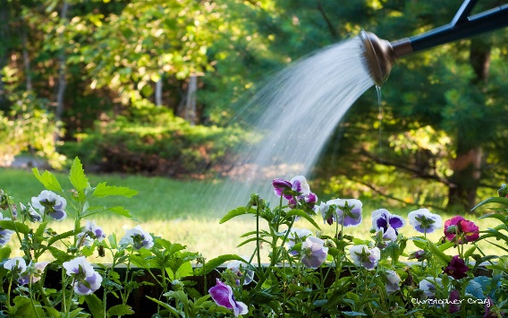

The Sioux City Garden Club was founded in 1926. We are a group from the Siouxland area whose common interest is gardening. In the fall and winter we have monthly meetings with speakers, demonstrations, great discussions about gardening and social time. Club meetings are held the third Monday of the month; September – April at 6:30 PM. In the summer we enjoy garden walks held on Monday evenings . The gardens include our own member’s gardens as well as other beautiful gardens throughout Siouxland. Our garden walks are popular, fun and inspirational. Each year we have 10-12 garden walks – they are great fun. Annual membership is $30.00 and includes all club activities including monthly meetings, garden walks and holiday party.
Visit our web site for information about our club activities www.siouxcitygardenclub.org

Send your membership application and check to:
Sioux City Garden Club
PO Box 3303
Sioux City, IA 51102

Name_______________________________

Address_________________________________________________________________ ____________________________________

Email_______________________________

Phone______________________________

